Project Development Phase
Model Performance Test

Date | 10 February 2025
Team ID | LTVIP2026TMIDS71321
Project Name | Dog Breed Identification Using Transfer Learning
Maximum Marks | 10 Marks

Model Performance Testing:
Project team shall fill the following information in model performance testing template.
S.No. | Parameter | Values | Screenshot
 | Metrics | Regression Model:  Regression metrics such as MAE, MSE, RMSE and R² score are generally used for continuous value prediction problems and are not applicable to image classification tasks.  Classification Model:  Confusion Matrix - , Accuray Score- 94% ,Classification Report – Includes precision, recall and F1-score for each breed | 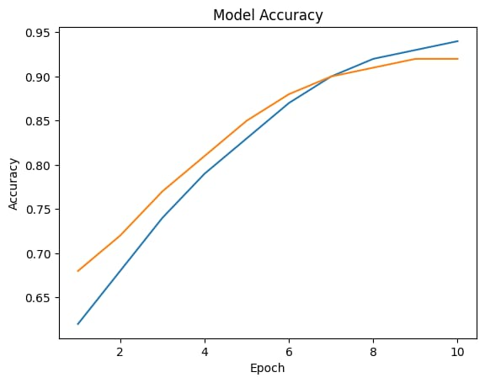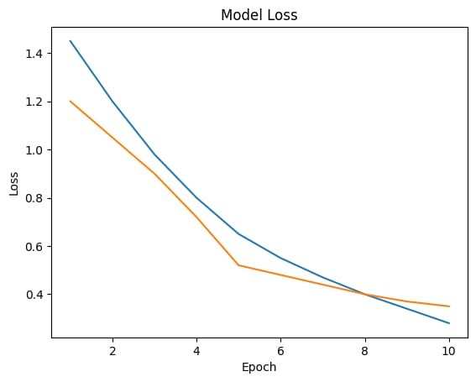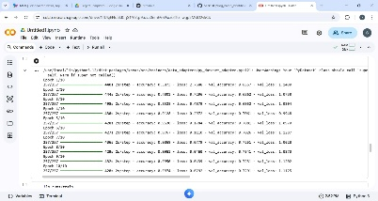
 | Tune the Model | Hyperparameter Tuning – Learning rate, batch size, and number of epochs were adjusted to improve model performance  Validation Method – Train-Test split method was used to validate the model performance | 